**TASK NO 01: Create a simple program to check whether the no is even or odd.**

**SOLUTION:**

int num;

Console.Write("enter any number: ");

num = int.Parse(Console.ReadLine());

if(num%2==0)

{

Console.WriteLine(" number is even ");

}

else

{

Console.WriteLine(" number is odd ");

}

**OUTPUT:**

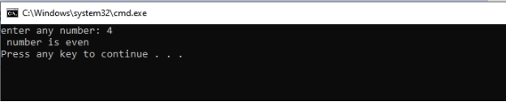

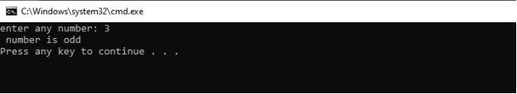

**TASK NO 02: Create a simple calculator using if else condition in which you will take two number as input and ask user which operation he/she wants to perform.**

**SOLUTION:**

{

double num1, num2;

Console.Write("enter your first number: ");

num1 = Convert.ToInt32(Console.ReadLine());

Console.Write("enter your second number: ");

num2 = Convert.ToInt32(Console.ReadLine());

Console.WriteLine("which action you want to perform?");

Console.WriteLine("1) addition");

Console.WriteLine("2) subtraction");

Console.WriteLine("3) multiplication");

Console.WriteLine("4) division");

Console.Write("enter your response: ");

double response = Convert.ToDouble(Console.ReadLine());

if(response==1)

{

Console.WriteLine("{0} + {1} = {2}",num1,num2,num1 + num2);

}

else if (response == 2)

{

Console.WriteLine("{0} - {1} = {2}", num1, num2, num1 - num2);

}

else if (response == 3)

{

Console.WriteLine("{0} x {1} = {2}", num1, num2, num1 * num2);

}

else if (response == 4)

{

Console.WriteLine("{0} / {1} = {2}", num1, num2, num1 / num2);

}

else

{ Console.WriteLine("invalid entry");

}

**OUTPUT:**

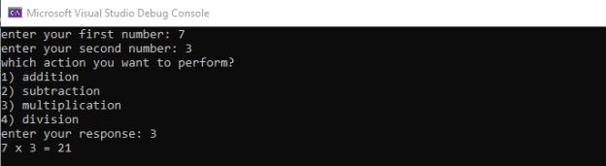

**TASK NO 03: Write a Program using nested ifs in which the user is asked to do the following:**

**Confirm if user wants to play the game “Guess the secret number”**

**If false, then print message “Maybe next time”; if true, then ask “Enter your age”**

**If age is less than 5 then print “You are too young to play”, else ask “Enter any number”.**

**If number is equal to the secret number then print “You have successfully guessed the secret number; else print “You were not successful in guessing the secret number”.**

**Note: You have to store a secret number in a variable in order to compare it.**

**SOLUTION:**

int choiceno;

int amount ;

int age ;

double luckyno = 1234;

Console.WriteLine("********** GAME\t\"Guess the secret number\"**********");

Console.WriteLine("\ndo you want to play the game if yes enter(y/Y) if no enter (n/N)");

Char input = char.Parse(Console.ReadLine());

if (input=='y'||input=='Y')

{

Console.Write("enter your age: ");

age = int.Parse(Console.ReadLine());

if (age>=5)

{

Console.Write("enter your amount: ");

amount = int.Parse(Console.ReadLine());

if (amount>=20)

{

Console.Write("enter your guessed secret number: ");

choiceno = int.Parse(Console.ReadLine());

if (choiceno==luckyno)

{

Console.WriteLine("You have successfully guessed the secret number");

}

else

{

Console.WriteLine("You were not successful in guessing the secret number");

}

}

else

{

Console.WriteLine("you have not fully amount to play the game");

}

}

else

{

Console.WriteLine("you are two young to play");

}

}

else

{

Console.WriteLine("***************EXIT******************");

}

**OUTPUT:**

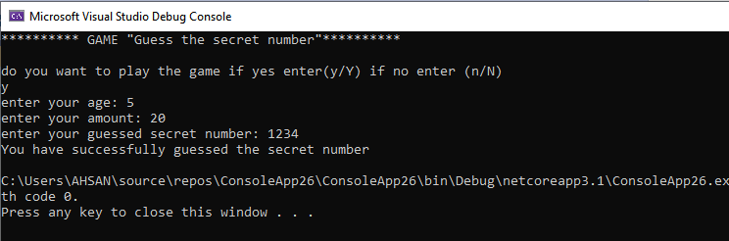

**TASK NO 04: Create simple application which will check the vowel using switch case.**

**SOLUTION:**

char alphabet ;

Console.Write("ENTER ANY ALPHABET: ");

alphabet = char.Parse(Console.ReadLine());

switch(alphabet)

{

case 'A':

case 'a':

case 'E':

case 'e':

case 'I':

case 'i':

case 'O':

case 'o':

case 'U':

case 'u':

Console.WriteLine(" THIS ALPHABET IS VOWEL");

break;

default:

Console.WriteLine(" THIS ALPHABET IS NOT A VOWEL");

break;

**OUTPUT:**

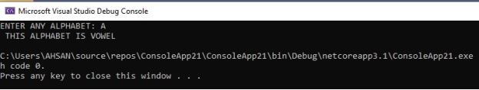

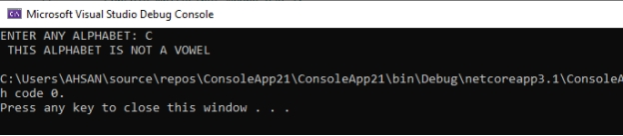

**\*\*\*\*\*\*\*\*\*\*\*\*\*\*\*\*\*\*\* BUKC CHECKING SYSTEM \*\*\*\*\*\*\*\*\*\*\*\*\*\*\*\*\*\*\*\*\*\*\*\*\*\*\*\*\*\***

**SOLUTION:**

double enr, nic;

string input,name, department, where;

DateTime dt = DateTime.Now;

Console.WriteLine("DATE: {0: dd:MMM: yyy}",dt);

Console.WriteLine("****** BUKC CHECKING SYSTEM******");

Console.WriteLine("1) are you bahrian(a/A)");

Console.WriteLine("2) are you alumnia(B/a)");

Console.WriteLine("3) are you outsider(c/C)");

Console.Write("\nenter your identity: ");

input = Console.ReadLine();

if (input == "a" || input == "A")

{

Console.WriteLine("*************************************");

Console.Write("\nenter your name: ");

name = Console.ReadLine();

Console.Write("enter your enrollment no: ");

enr = Convert.ToDouble(Console.ReadLine());

Console.Write("enter your department: ");

department = Console.ReadLine();

Console.WriteLine("***THANKS FOR VISITING***");

Console.WriteLine("*************************************");

}

else if (input == "b" || input == "B")

{

Console.WriteLine("*************************************");

Console.Write("\nenter your name: ");

name = Console.ReadLine();

Console.Write("enter your enrollment no: ");

enr = Convert.ToDouble(Console.ReadLine());

Console.Write("enter your department: ");

department = Console.ReadLine();

Console.WriteLine("***THANKS FOR VISITING***");

Console.WriteLine("\n*************************************");

}

else if (input == "c" || input == "C")

{

Console.WriteLine("*************************************");

Console.Write("\nenter your name: ");

name = Console.ReadLine();

Console.Write("enter your enrollment no: ");

enr = Convert.ToDouble(Console.ReadLine());

Console.Write("where you want to go: ");

where = Console.ReadLine();

Console.WriteLine("***THANKS FOR VISITING***");

Console.WriteLine("*************************************");

}

else

{ Console.WriteLine("****wrong person****"); }

**OUTPUT:** 